Recording the desktop on OSX

For recording the desktop you’ll need two applications:
CamTwist – http://camtwiststudio.com/
Open Broadcaster Software – https://obsproject.com/

Download and install CamTwist and Open Broadcaster Software.
Next up is the configuration of the two packages, I’ll try to explain the configuration below.

To prepare CamTwist for the recording of RocketChat:
There are several steps you can choose, I’ll explain which choices are preferred.
Step 1: Choose Desktop+
Step 2: Not important keep default
Step 3: Not important keep default
In settings choose Confine to application Window (Filter out untitled windows, and Select from existig windows: Choose Rocket Chat).
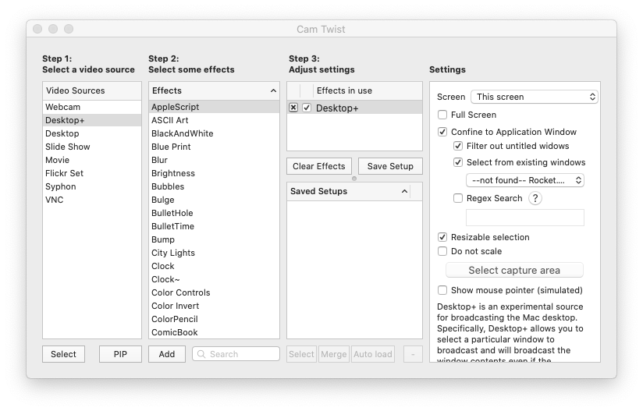

To prepare Open Broadcaster Software for the recording of RocketChat.
In “Sources” select “Video Capture Device”.
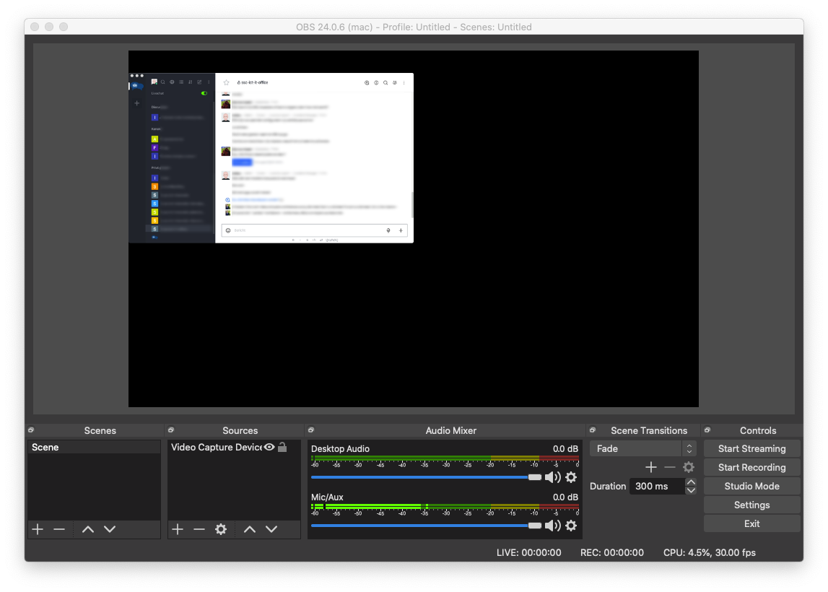

Next up is connecting OBS to CamTwist.
In properties “Video Capture Device” select CamTwist as a device.
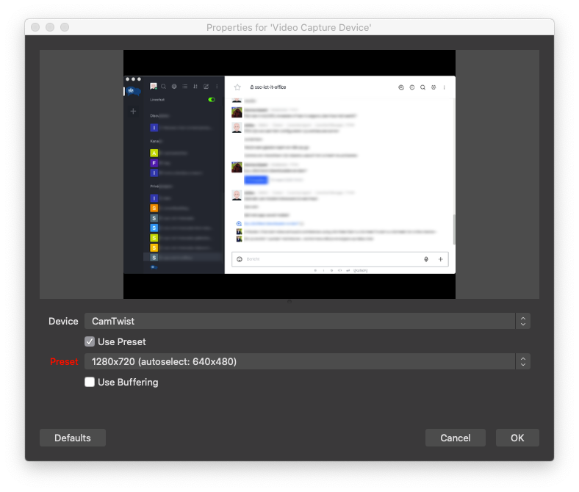

Next thing to do is to press the button “Start Recording” and start your show :-)

